Basic Search Engine Optimization (SEO)
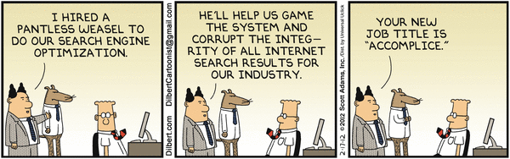

Introduction
The goal of SEO is to increase your site’s position in search engine response lists when people type key phrases into search engines
You want to make your site more appealing to search engines so that they will give you more traffic when people search for what your website has to offer.
Traffic that occurs when people click on a search engine response listing for your site is called organic (free) traffic

Target key phrase Research

Search engines do two things
First, they categorize sites
Second, they rank them by relevance within a category
People normally only visit the first few sites in the search engine list when they do a query

You need to
Help search engines understand your categories
Convince them to rank you highly for certain chosen queries

Search engines fight SEO
Want to categorize pages “naturally”
Fight actions like repeating the same phrase a million times on a page
Constantly change their strategies

Key Phrases

Search engines use key phrases to determine relevance
Key phrases are words or phrases that characterize your site
Money
Make Money at Home

Target Key phrases
You need to identify good key phrases to characterize your site’s webpages
You need to anticipate what key phrases searchers will use
In jargon, you need to select target key phrases

Many key phrases are highly competitive
“Make money”
Do not try to fight these by selecting them as your key phrases
Established sites will almost always win for popular key phrases
This makes sense because they have more traffic
In addition, they have more SEO expertise than you will
Your ranking will be so low on the response list that nobody will find you

Choose a less competitive target key phrase
More specific
“Make money on eBay”
“Make money with a good eBay strategy”
Concept
Bad: Fewer searches will point to you
Good: If people use them in a query, you will be ranked high enough to have a chance

Finding key phrases that do this requires a great deal of thought

Select A Few key phrases
But not too many

Use synonyms
Search engines like synonyms rather than mindless repetition
Search engines call this latent semantic indexing
“Six pack abs” “flat tummy,” “tone your midsection” etc.
Write naturally: Key phrases should only be 2% to 5% of your content
You will be rewarded for this

On-Site SEO Actions
Things that you can build into your site
Search engines pay more attention to certain parts of your site than to others

Domain Name
Should include your key phrase

Don’t Put key phrases in images
Search engines can’t read them

Focus Each Page on a Specific Key phrase
Content should include it
2% to 5% of time use the key phrase or synonyms

Title
<title>xxxxxx</title>
Quite important in SEO. Put your key phrase here
Words near the front are rated higher

Meta Tag: Keywords
<meta name=”keywords” content=”make money, make money online, how to make money online”>
3-10 keywords/key phrases
Use these in the page content
Search engines are wary of meta tags

Anchor Text
<a href=”xxx”>This is anchor text</a>
Search engines consider this significantly
Use key phrases
Internal links within sites are good
External links from other sites are better

<h1>, <h2>, <h3>, <h4>, <h5>, <h6>
Usually, one h1 on a page
Multiple h2s
Search engines consider these, especially h1s and h2s

Body Copy
Use your key phrases
Use synonyms instead of just repeating the key phrases
But write naturally

Frequently Update Your site
Search engines like this
XML compliant site map

External SEO Actions
More powerful but expensive and difficult to do
Get popular sites to link to you
Top sites have legitimacy
The fewer sites a popular site links to the better
In general, you need to hire a search engine optimization guru

